**SPRING CORE AND MAVEN**

**EXERCISE 1: CONFIGURING A BASIC SPRING APPLICATION**

**Pom.xml**

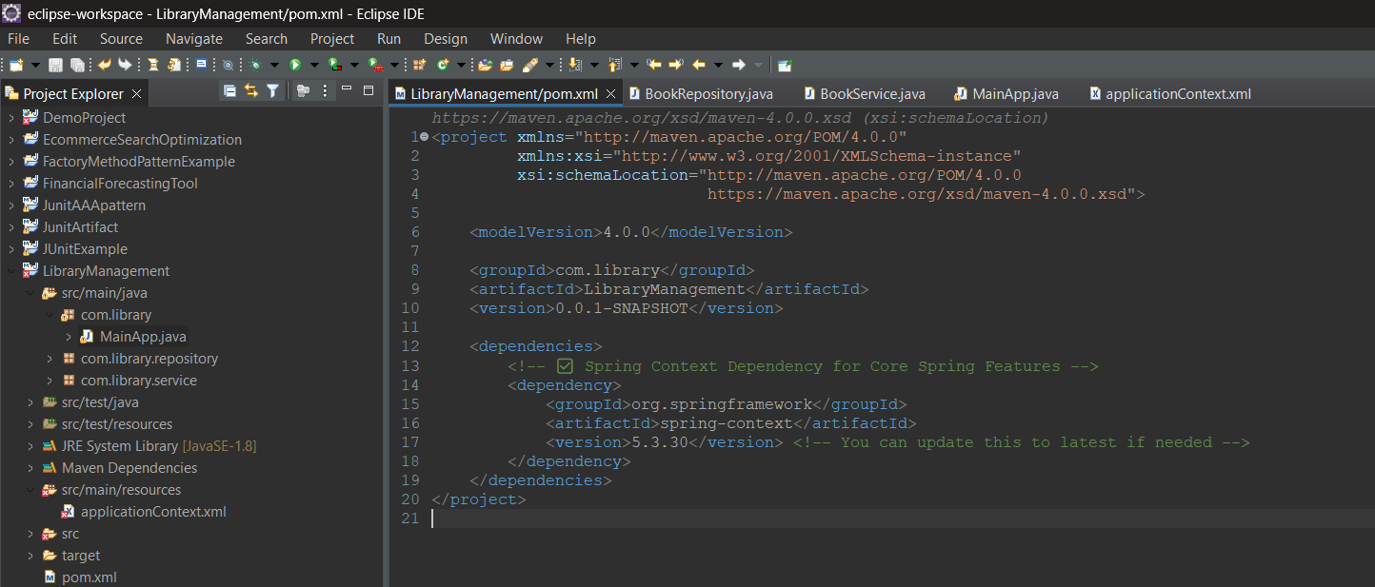

**BookRepository.java**

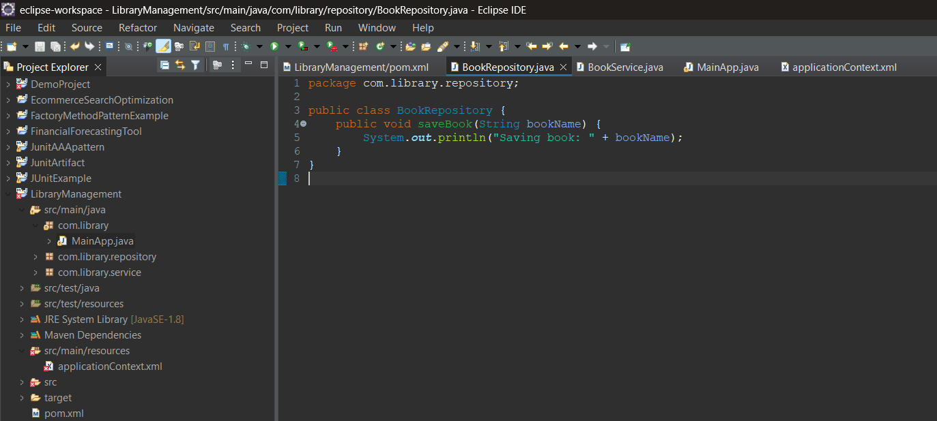

**BookService.java**

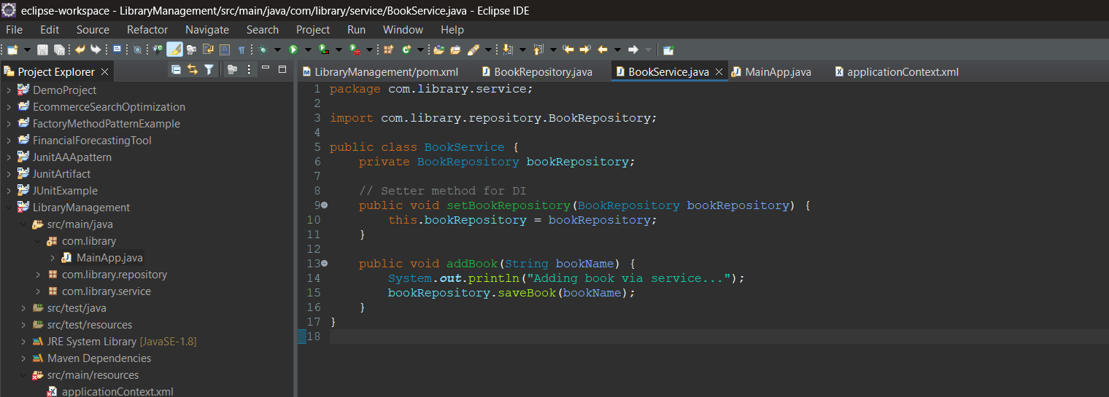

**MainApp.java**

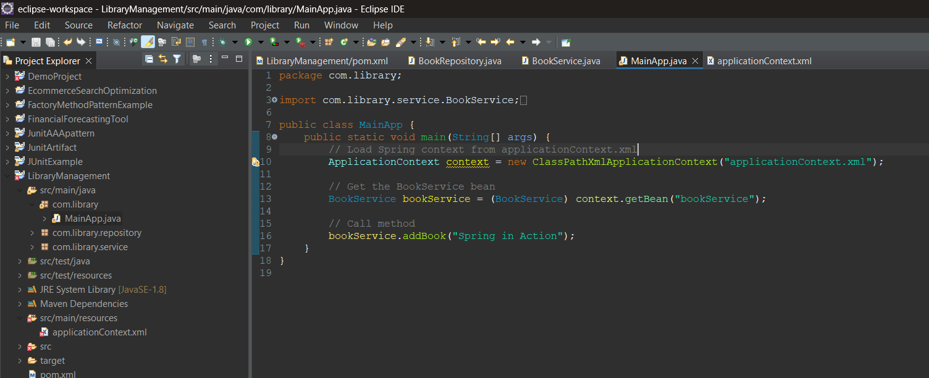

**applicationContext.xml**

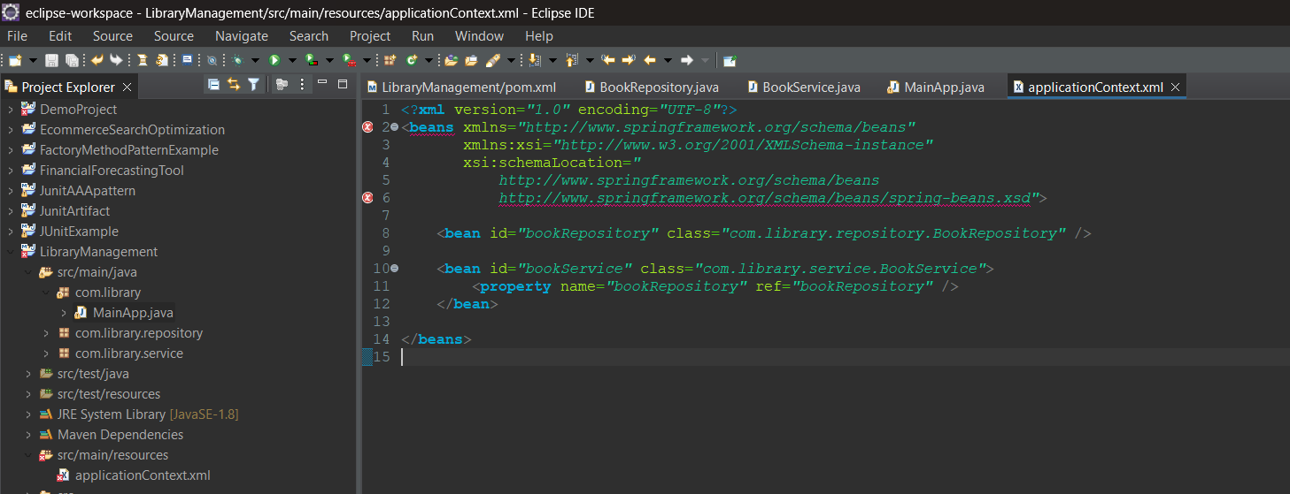

**Output**

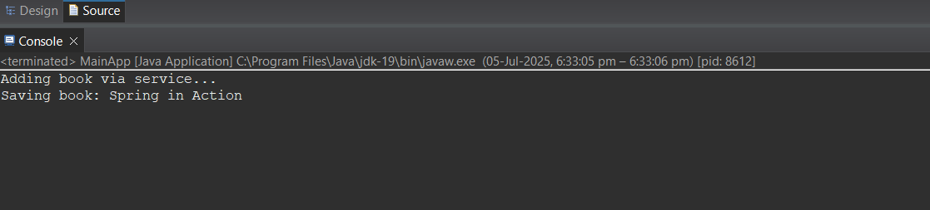

**EXERCISE 2: IMPLEMENTING DEPENDENCY INJECTION**

**Pom.xml**

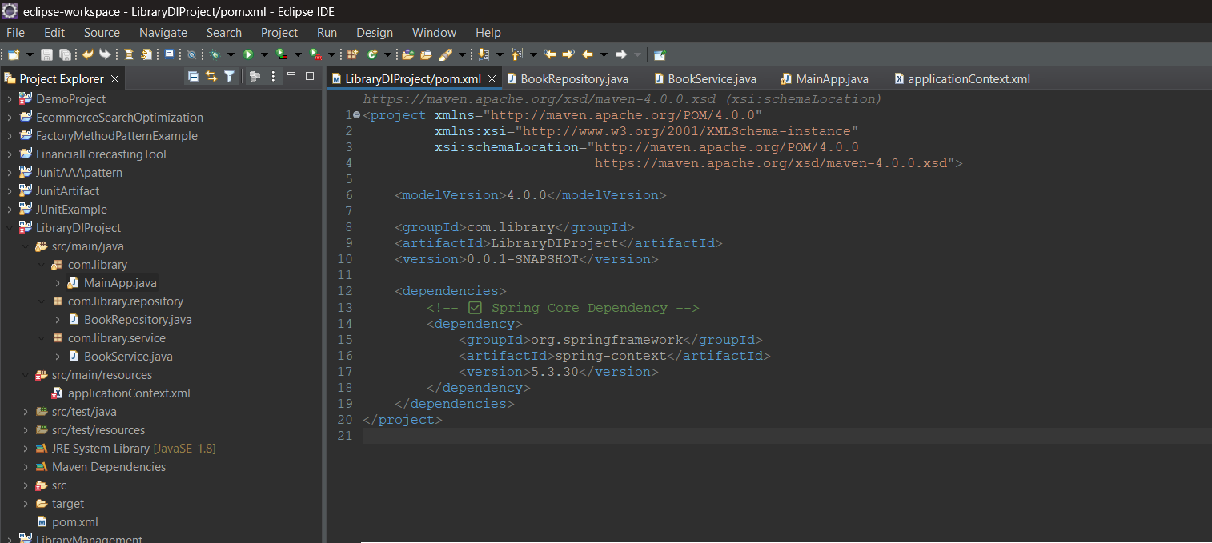

**BookRepository.java**

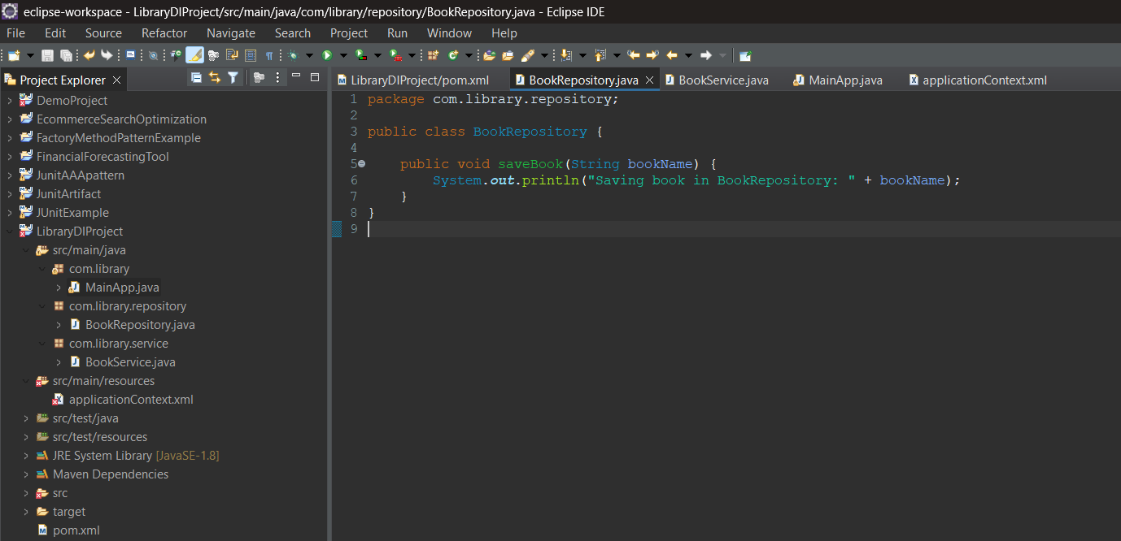

**BookService.java**

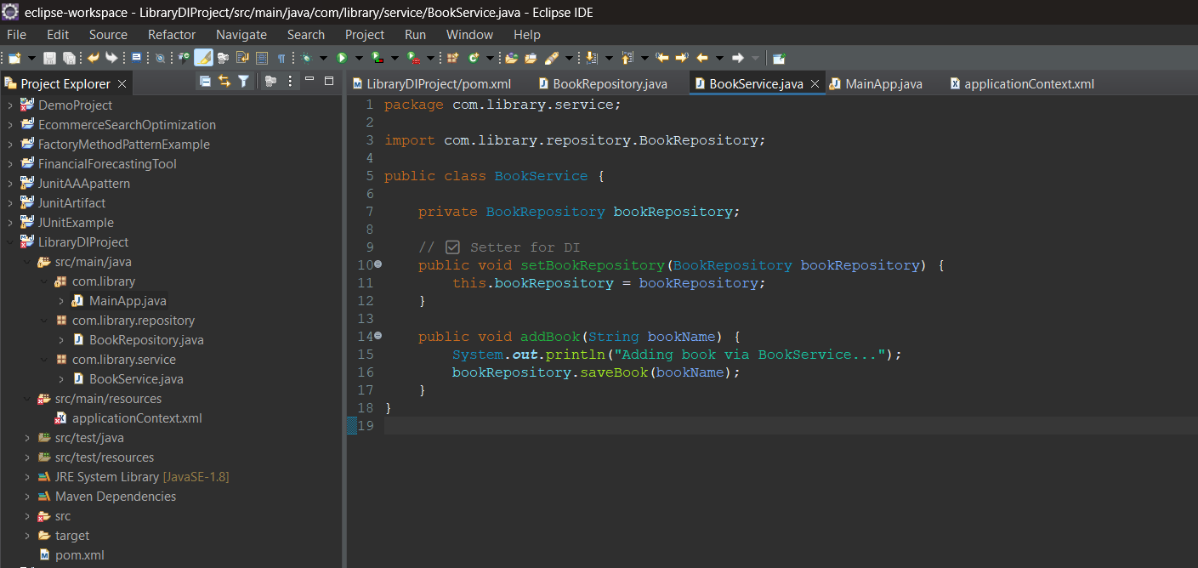

**MainApp.java**

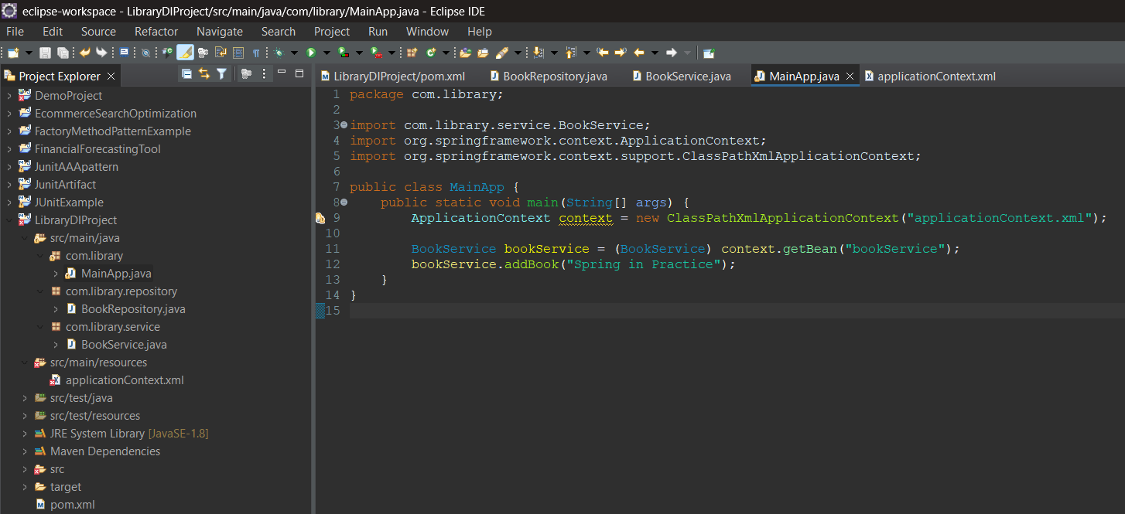

**applicationContext.xml**

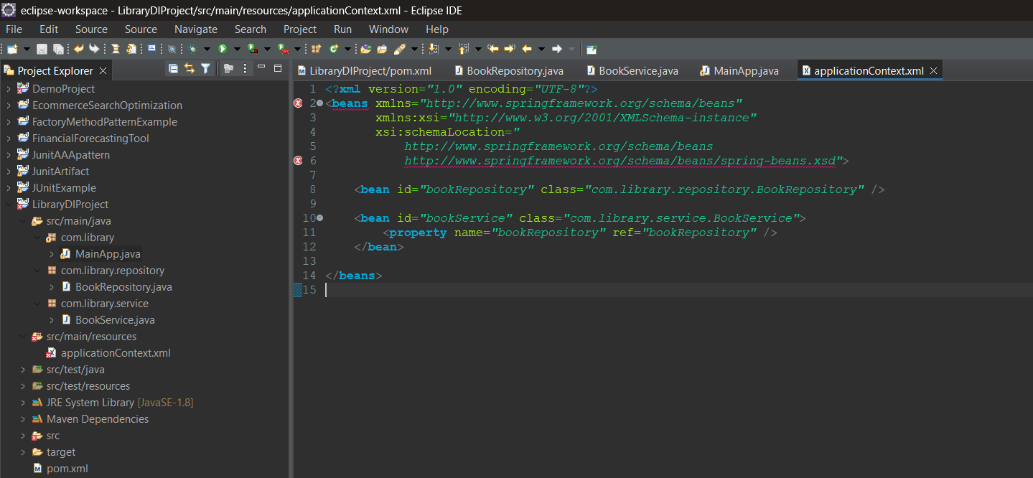

**Output**

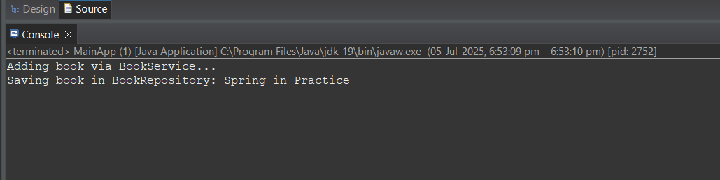

**EXERCISE 4: CREATING AND CONFIGURING A MAVEN PROJECT**

**Pom.xml**

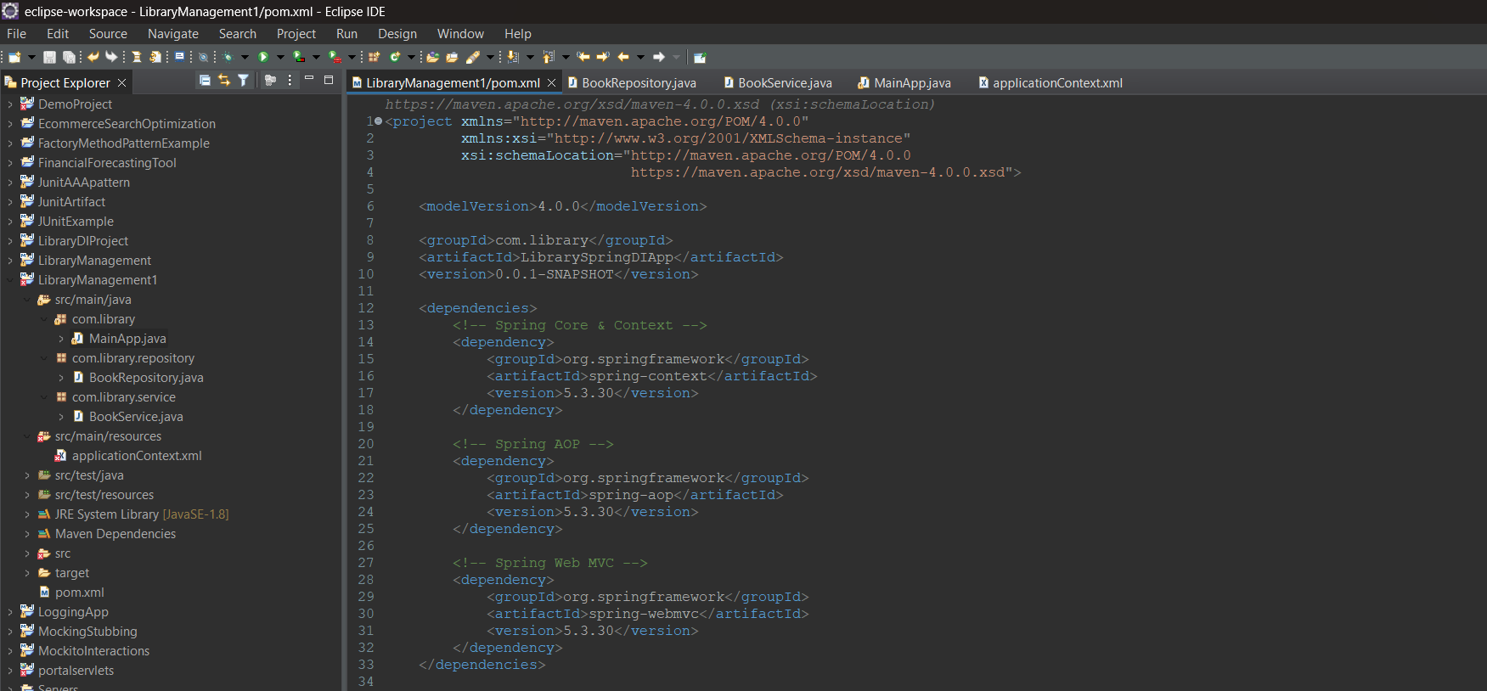

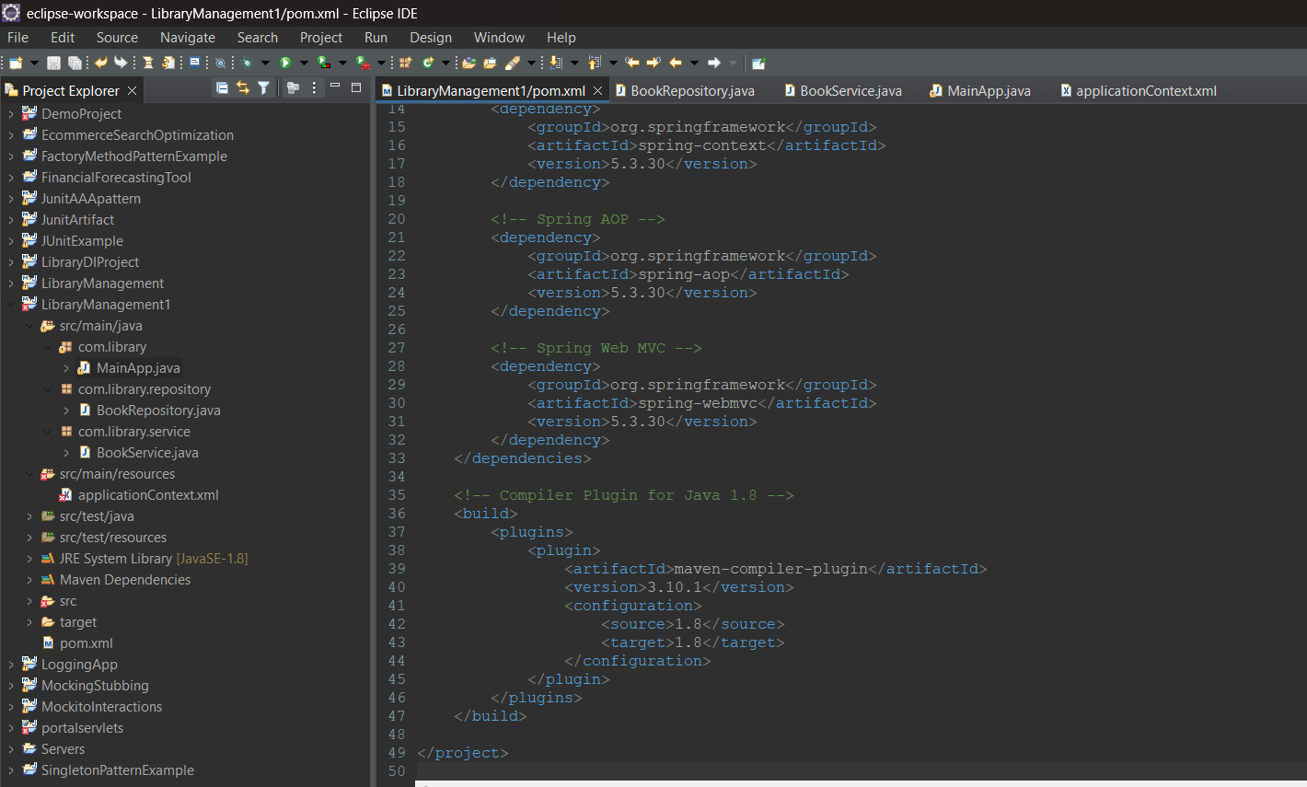

**BookRepository.java**

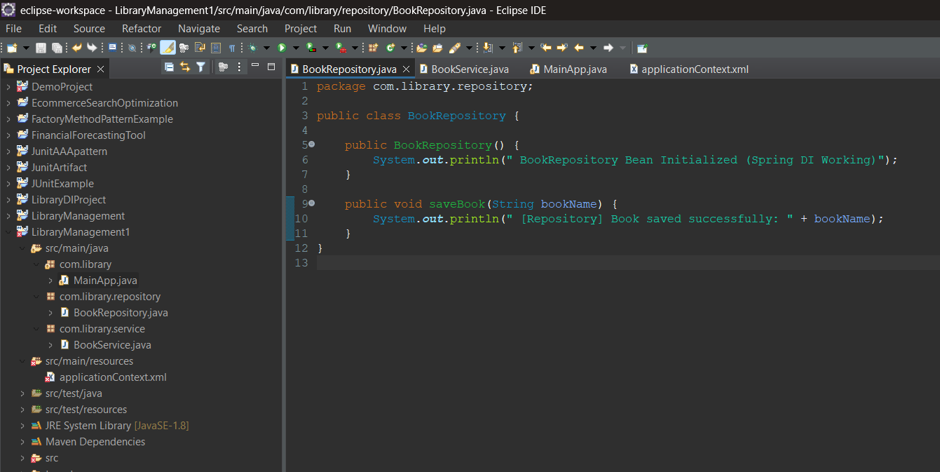

**BookService.java**

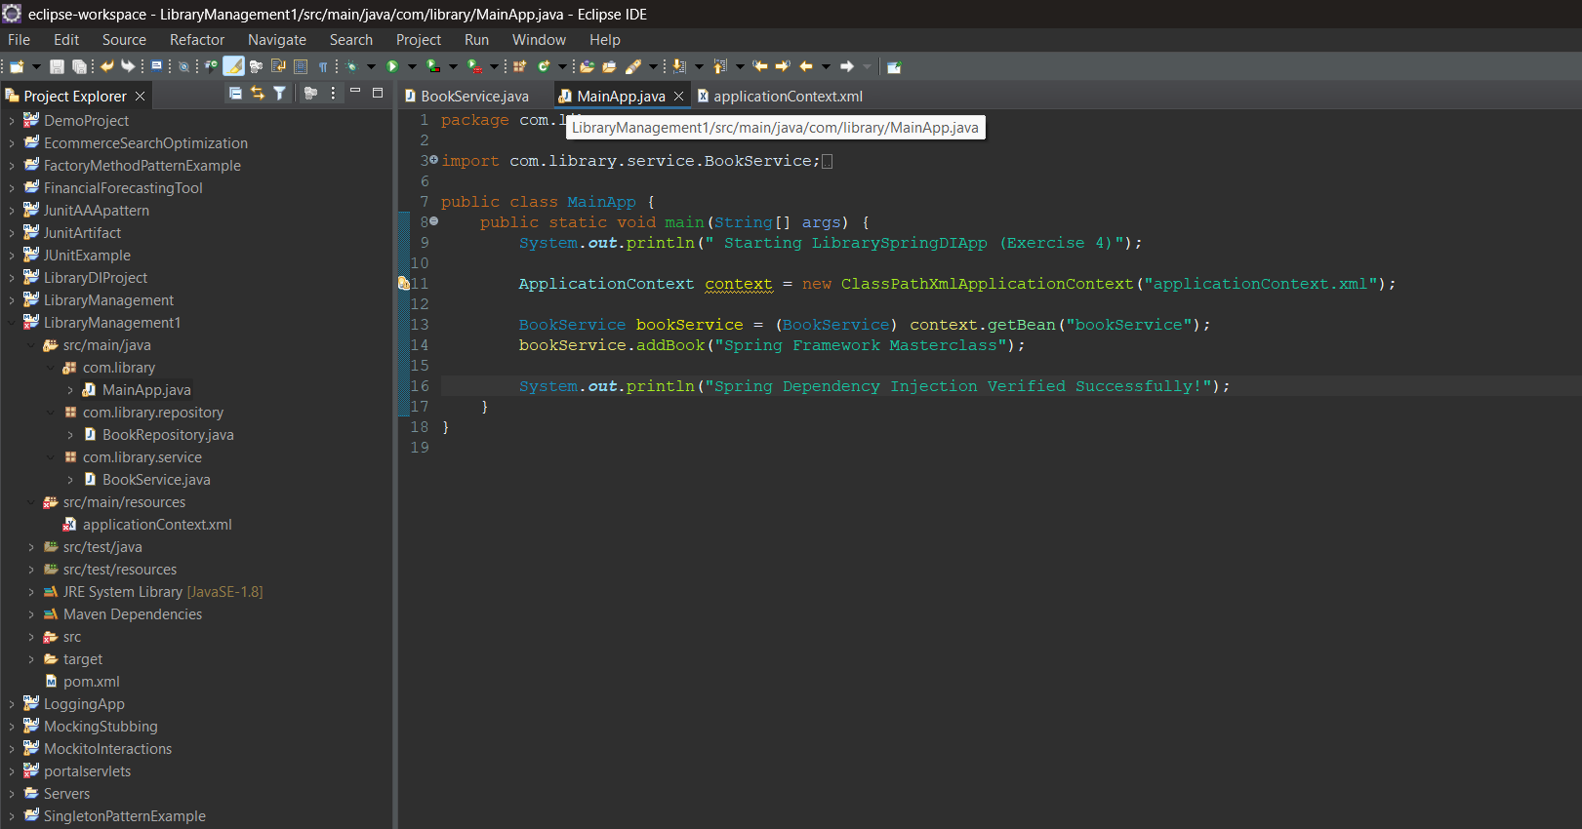

**MainApp.java**

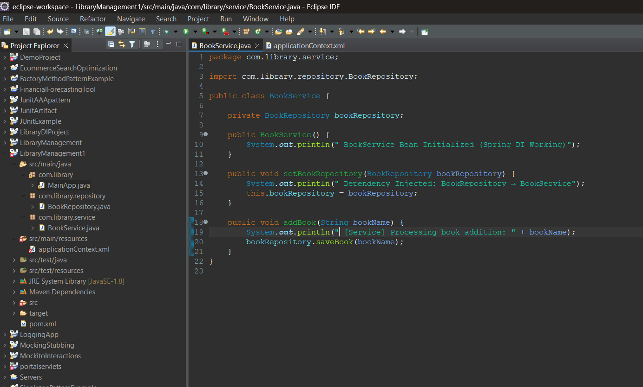

**applicationContext.xml**

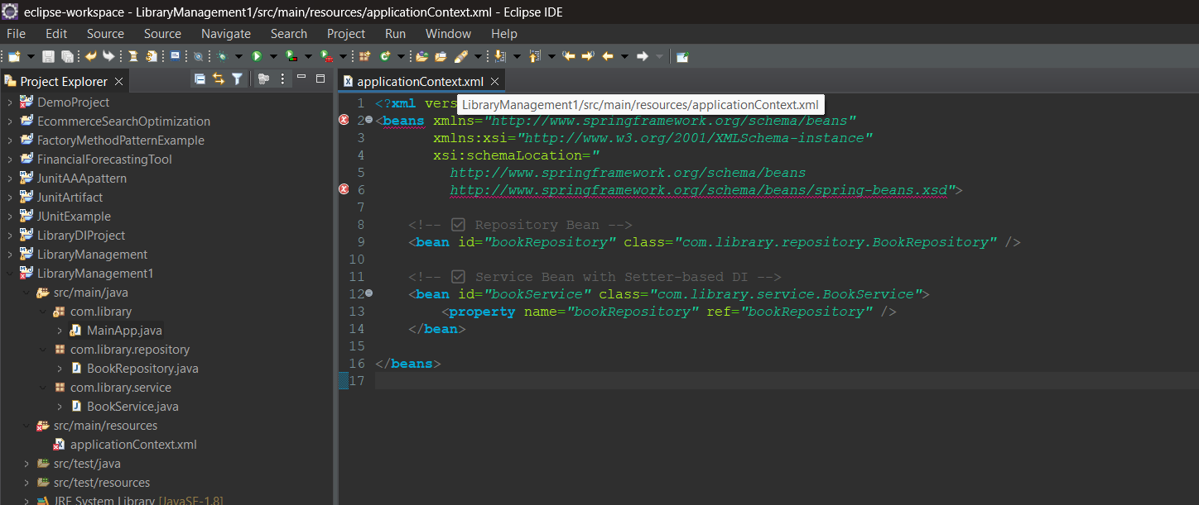

**Output**

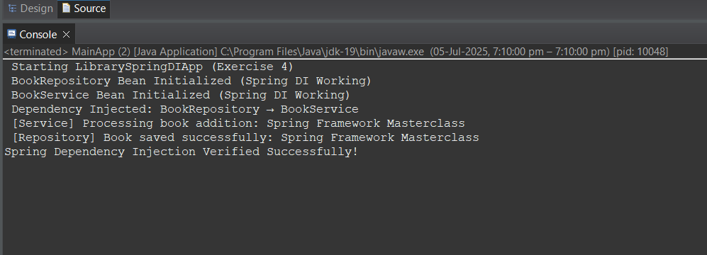

**SPRING DATA JPA WITH SPRING BOOT, HIBERNATE**

**SPRING DATA JPA - QUICK EXAMPLE**

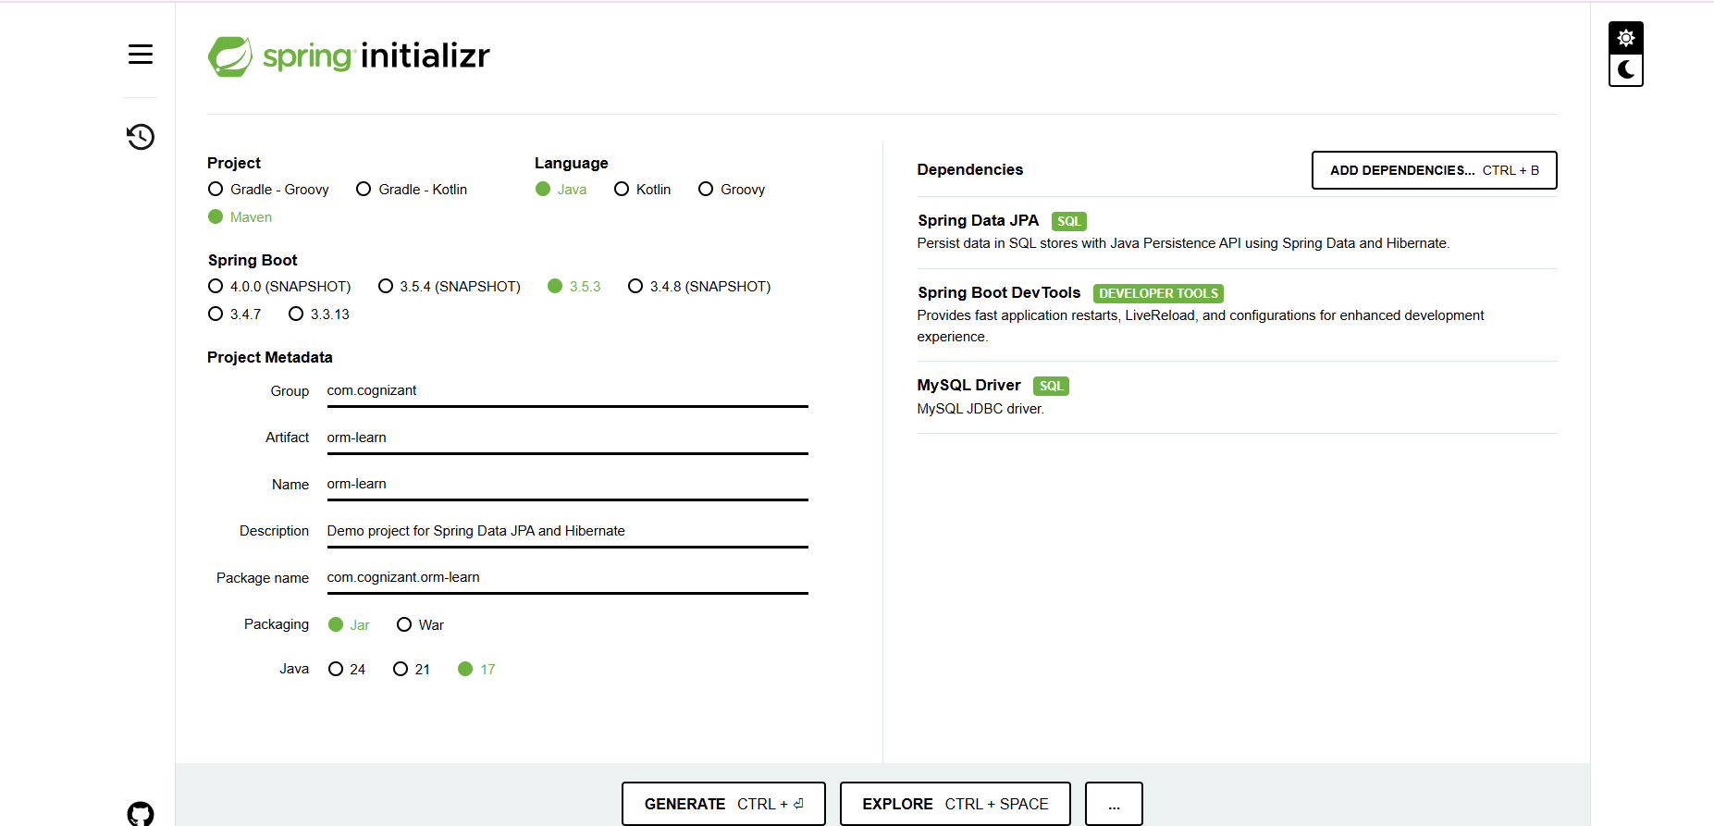

**MySQL**

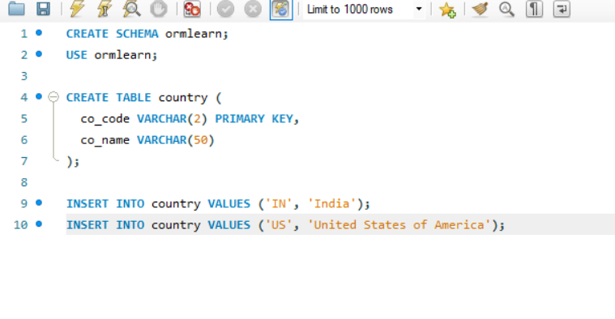

**Pom.xml**

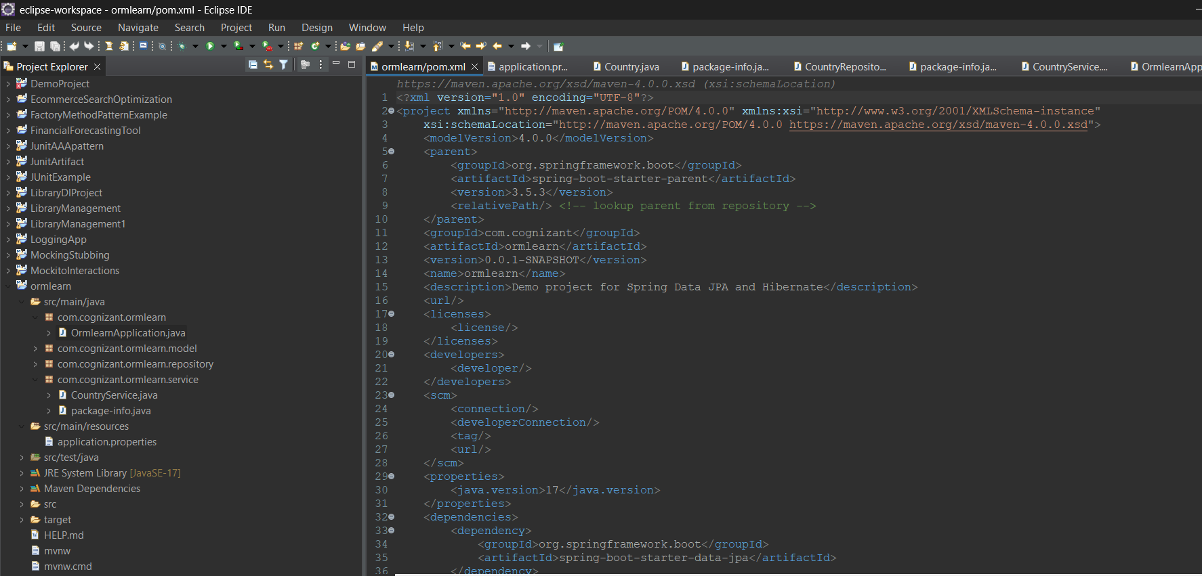

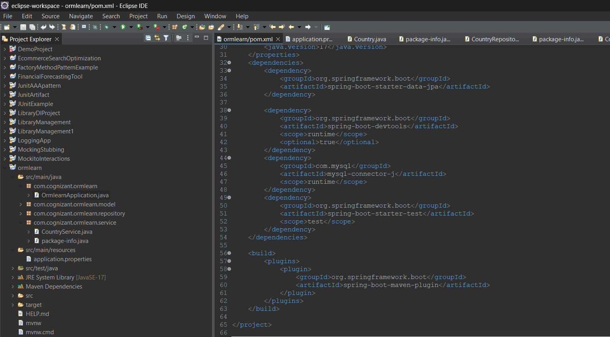

**Application.properties**

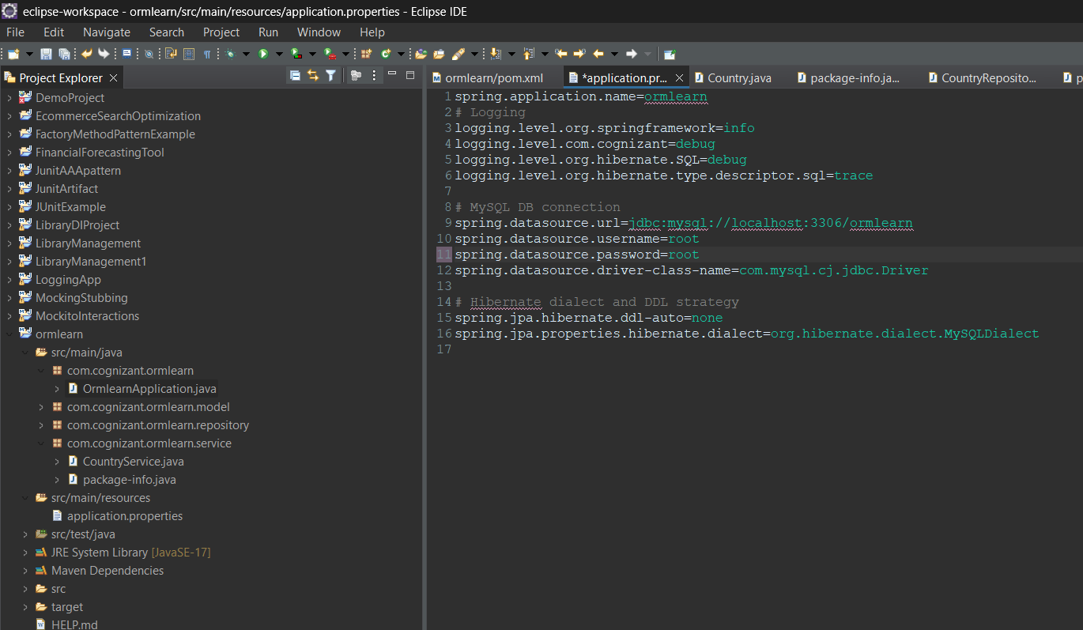

**Country.java**

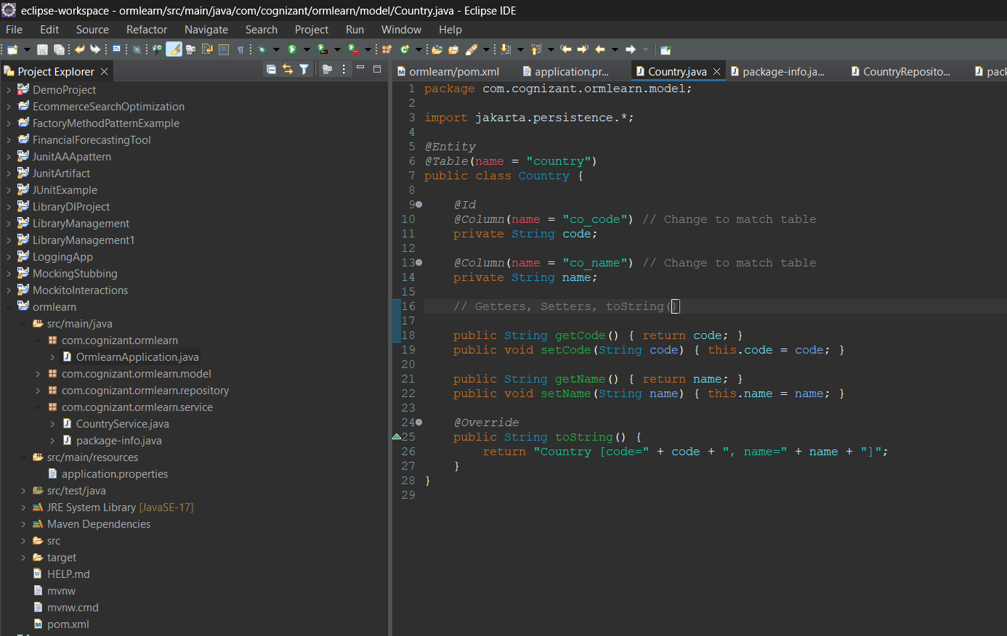

**CountryRepository.java**

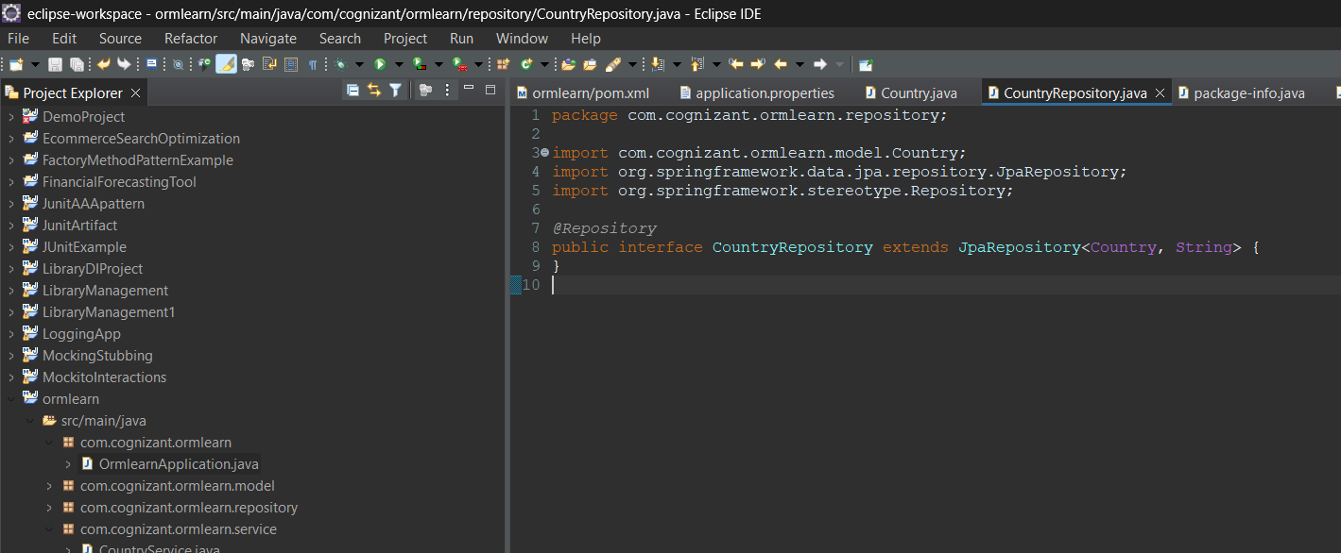

**CountryService.java**

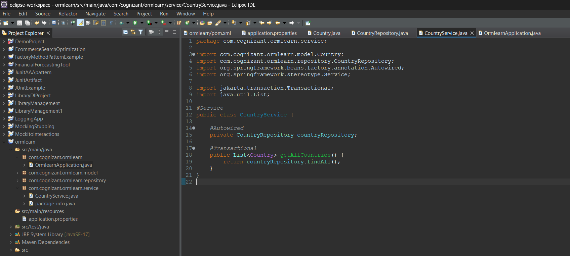

**OrmlearnApplication.java**

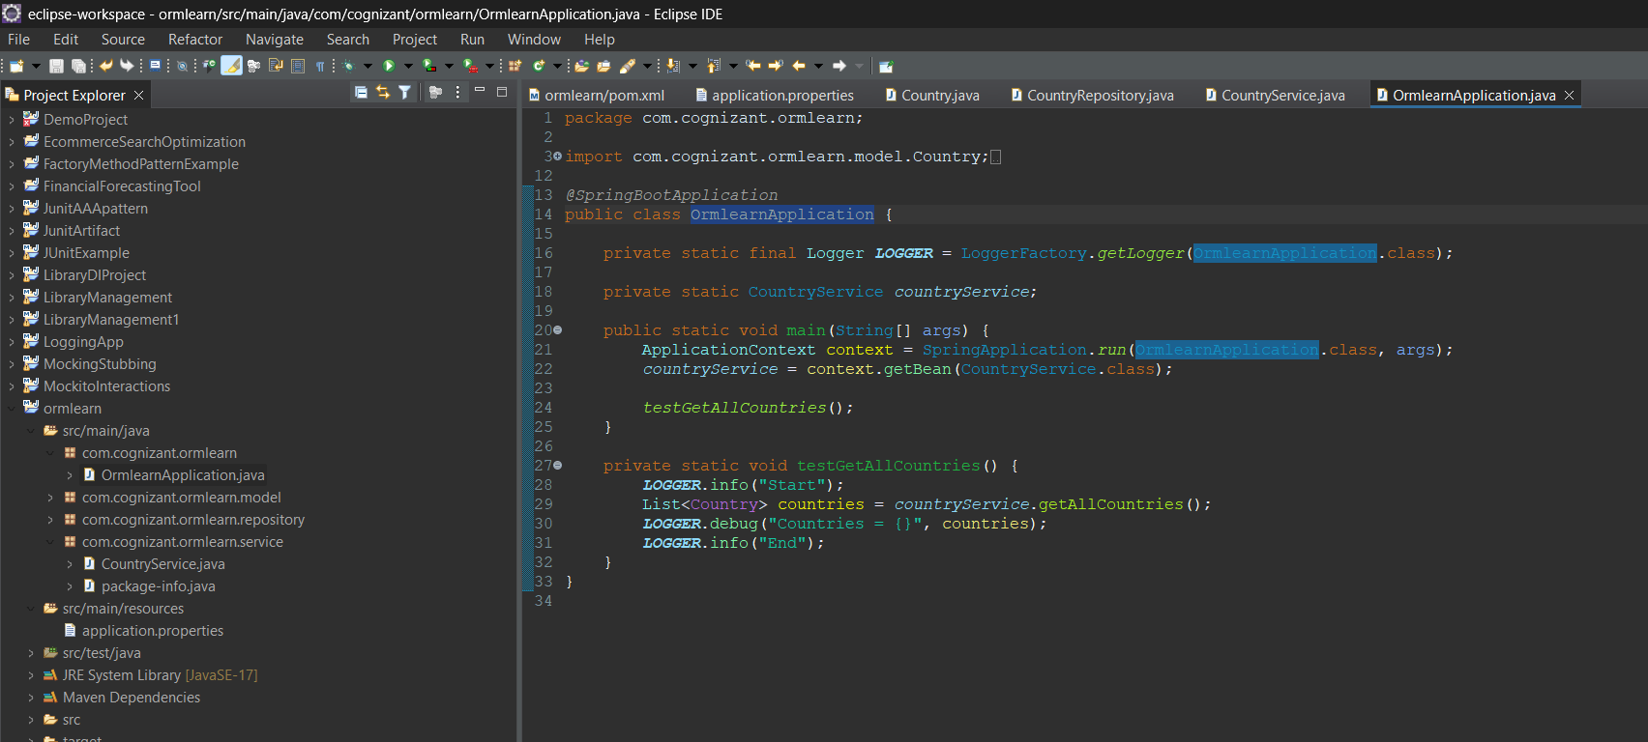

**Output**

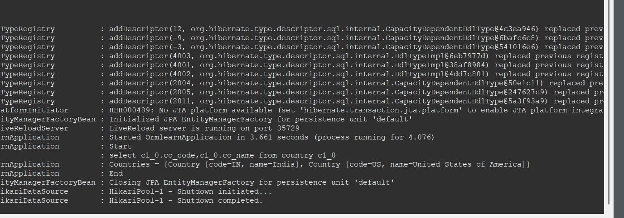

**DIFFERENCE BETWEEN JPA, HIBERNATE AND SPRING DATA JPA**

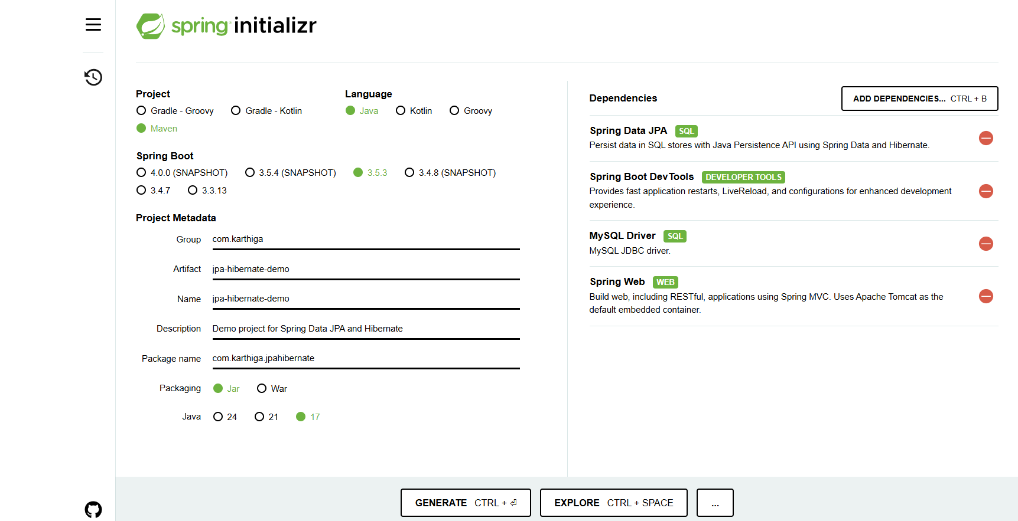

**MySQL**

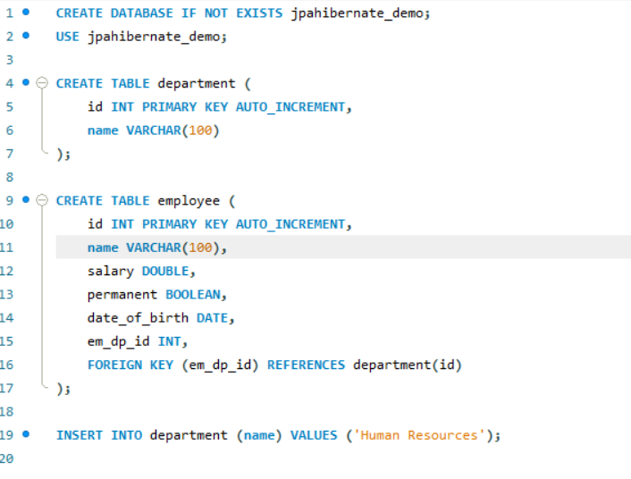

**Application.properties**

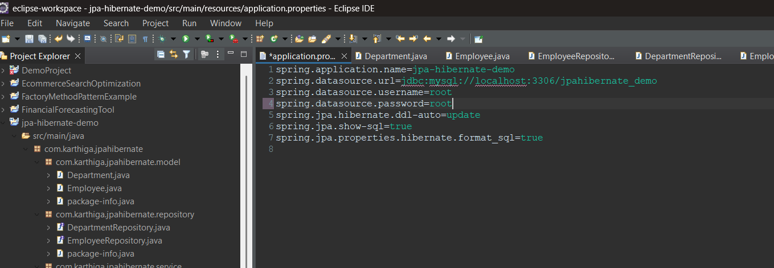

**JpaHibernateDemoApplication.java**

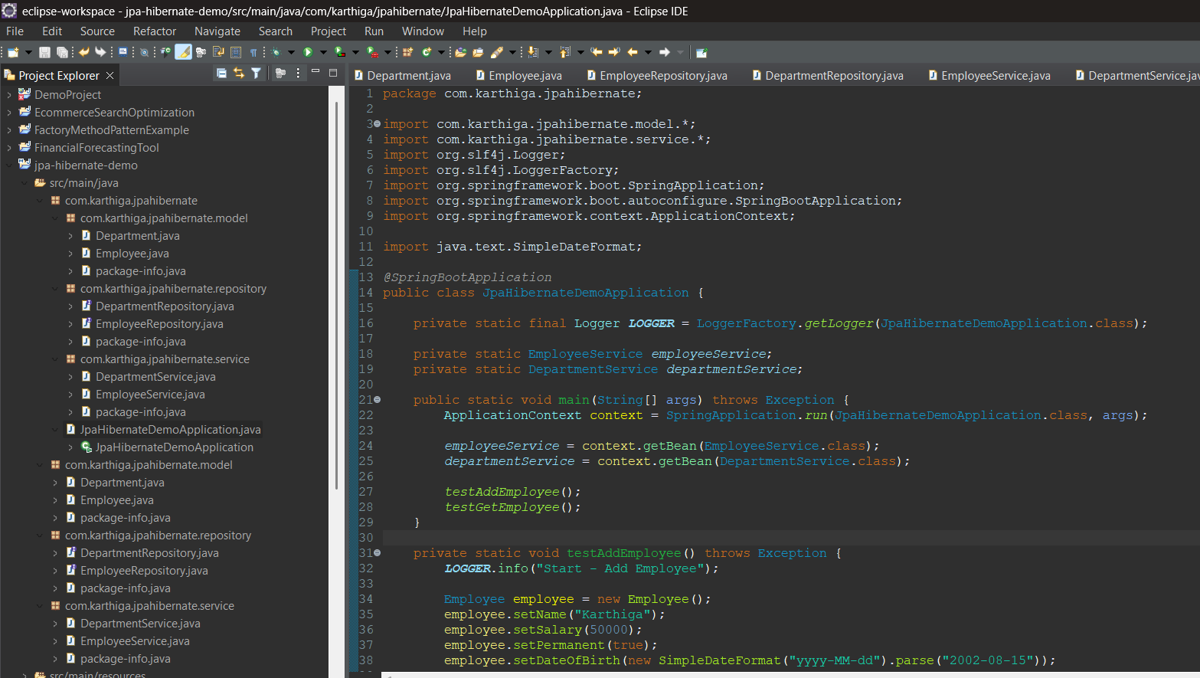

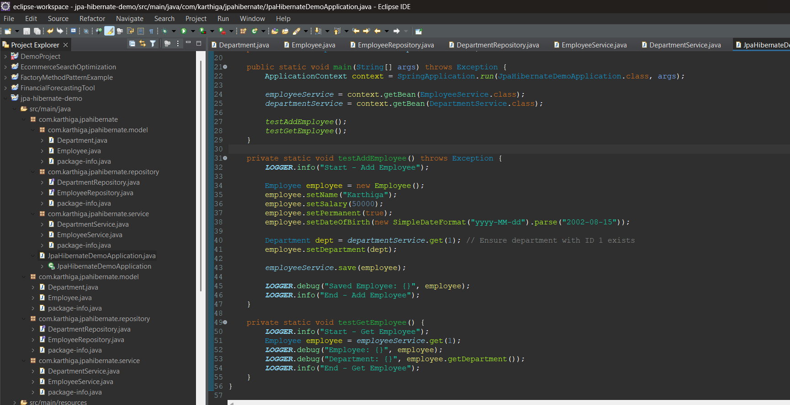

**Department.java**

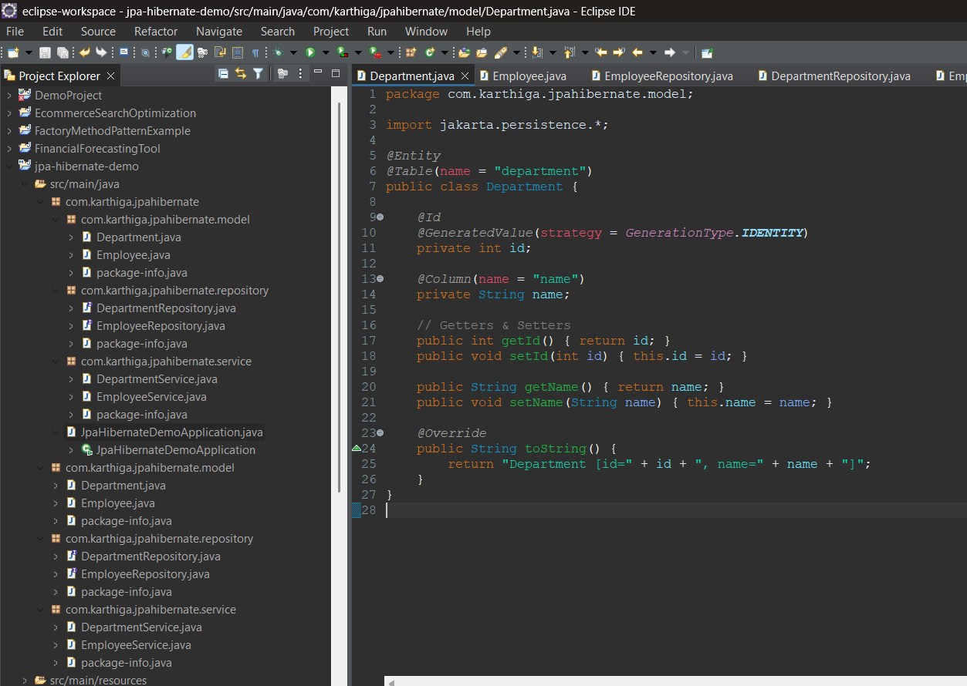**Employee.java**

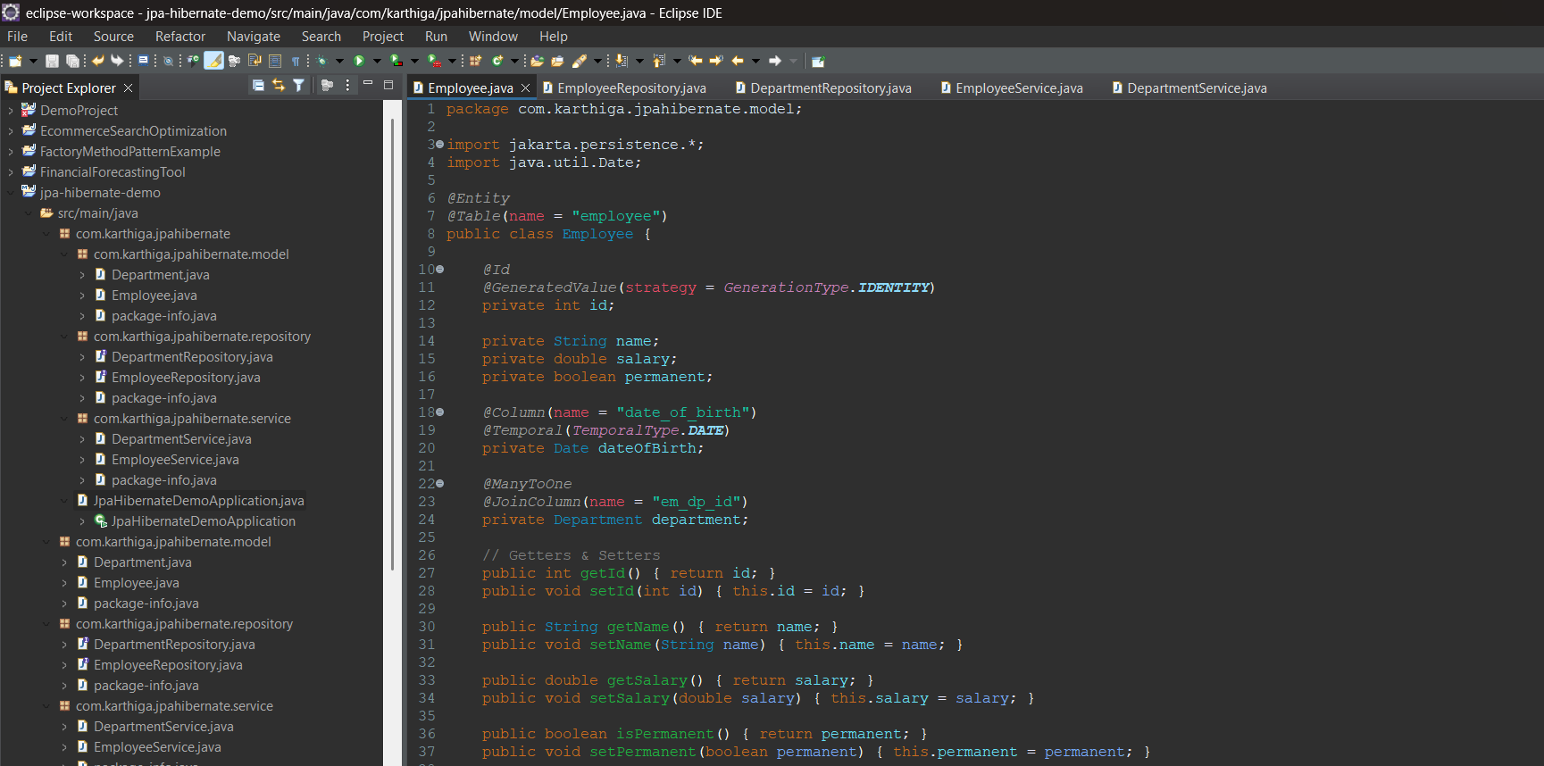

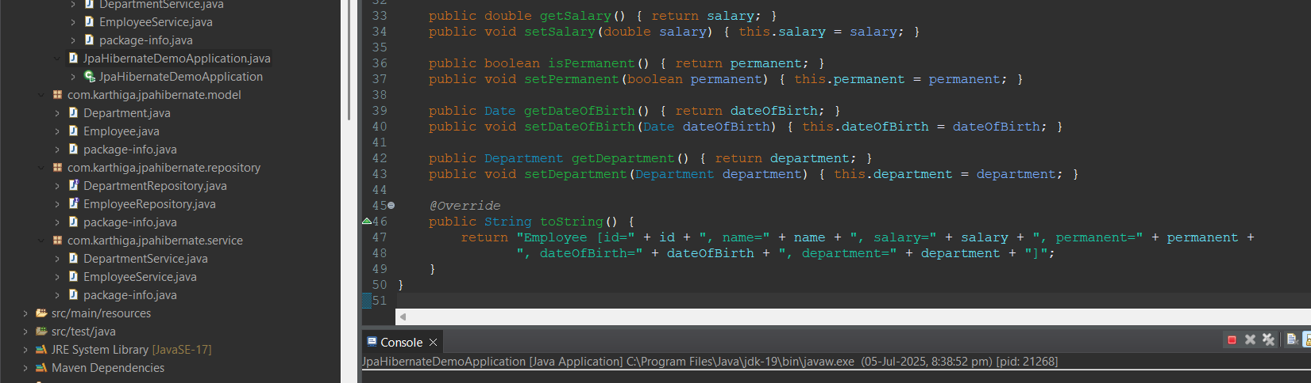

**EmployeeRepository.java**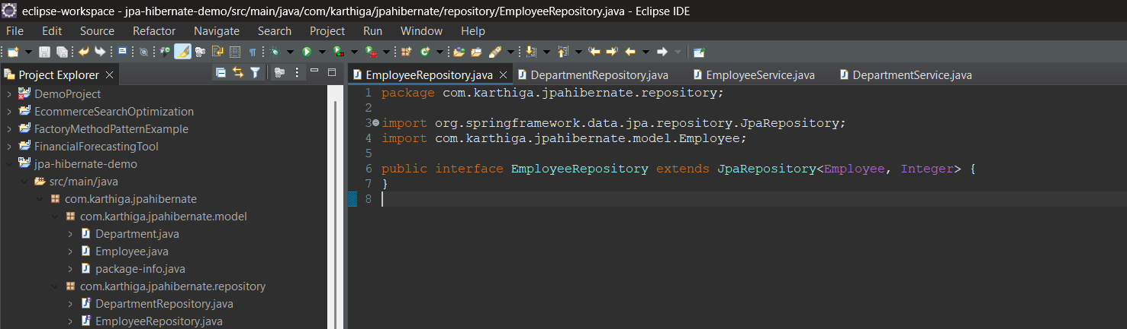

**DepartmentRepository.java**

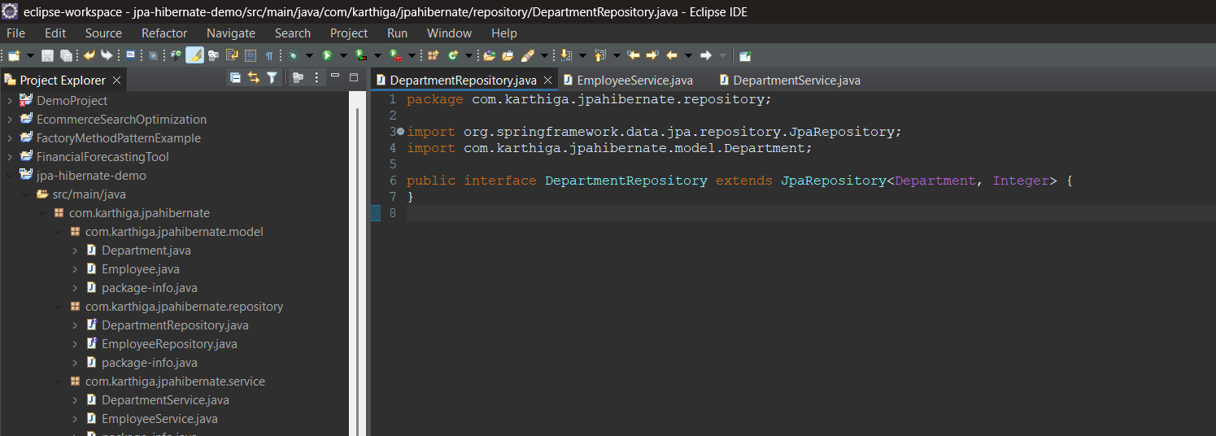

**EmployeeService.java**

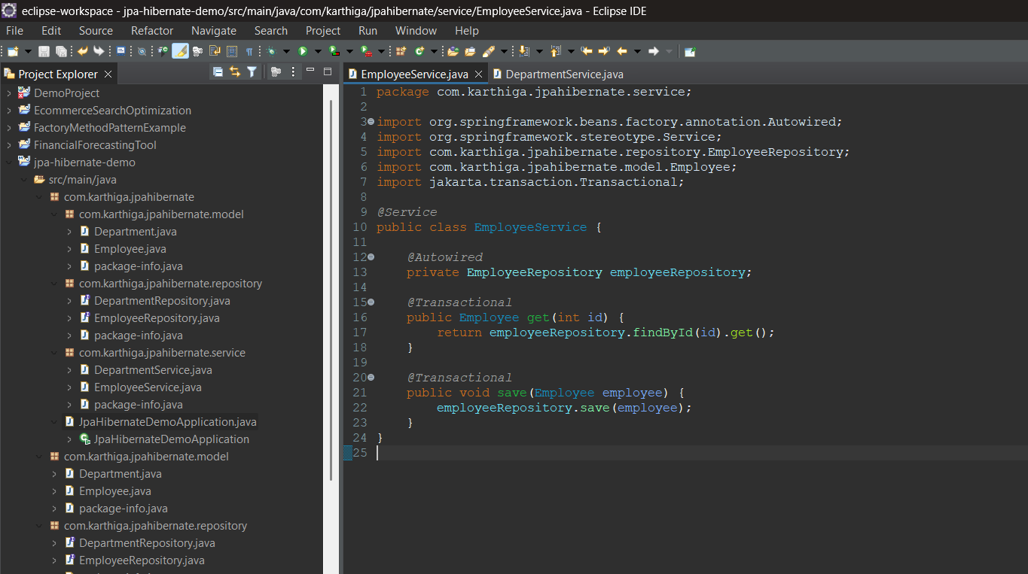

**DepartmentService.java**

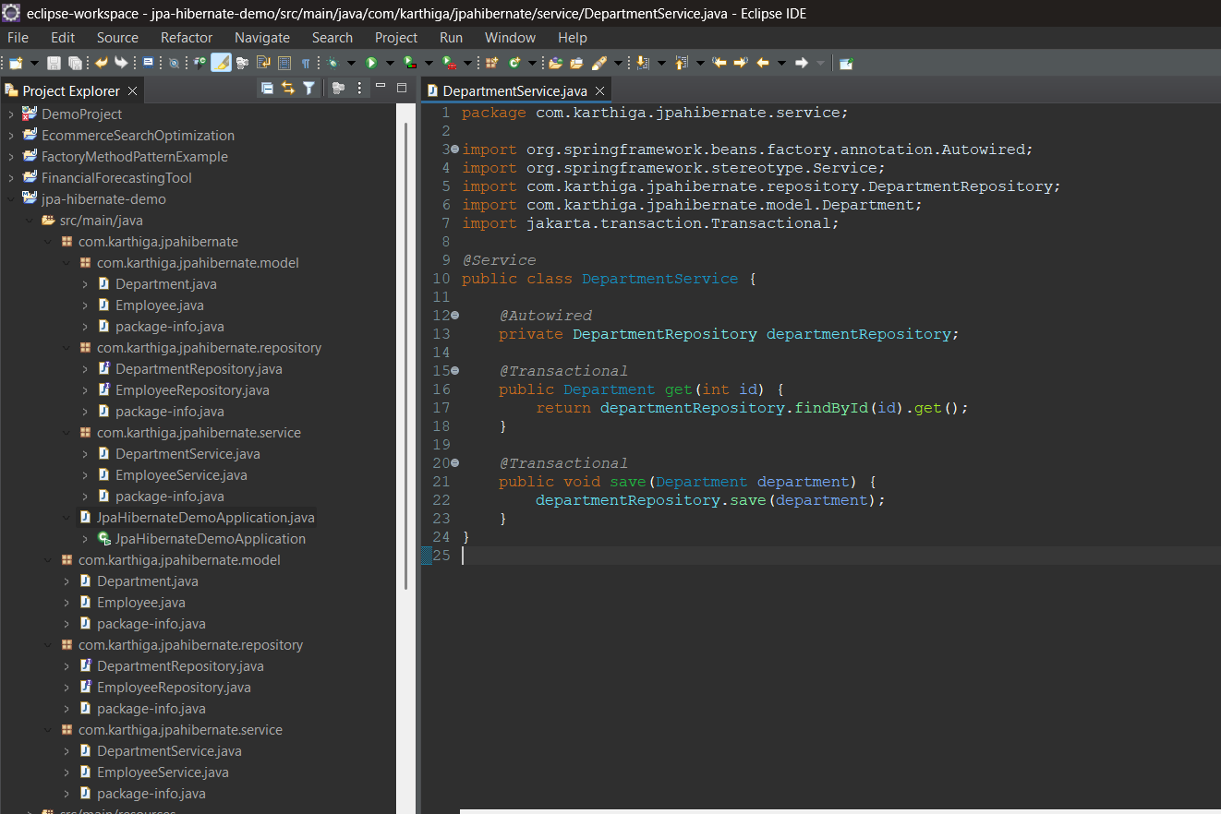

**Output**

